# Programming 220920

## Task

We have N students (ordered by their name) with their name and length.

Decide whether the order of names and length are the same or not?

Example

6 NO

Anna 168

Bea 174

Csaba 172

Dominik 172

Erik 176

Ferenc 180

## Design

### Task Specification

|  |  |
| --- | --- |
| **Input $$N∈N$$ $$h∈N^{N}$$** | **Pre-condition $$N≤100$$** |
| **Output $$inOrder∈L$$** | **Post-condition $$inOrder≡∀i \left(2≤i≤N\right):h_{i-1}≤h_{i}$$**  data in h is ordered  every data in h greather than the previous |

### Program Specification

|  |  |
| --- | --- |
| **Input**  N:Integer  h:IntegerN | **Pre-condition**  N<=100 |
| **Output**  inOrder:Logical | **Post-condition**  inOrder =DECISION(h,2,N,h[i-1]<h[i]) $$inOrder=\begin{matrix}\begin{matrix}N \\ DECISION \\ i=2\end{matrix} & (h,h_{i-1}≤h_{i})\end{matrix}$$ |

### Algorithm

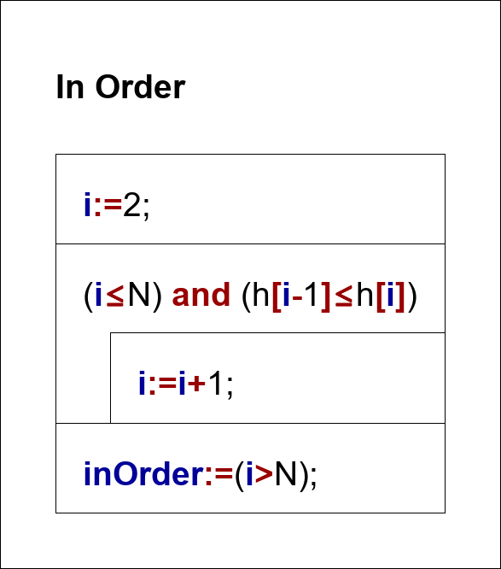

## Implementation

C# in Visual Studio